Displays

LOTI.05.010 Robotics

Spring semester 2015/16

Practice session 3
The aim of this lab is to learn to different types of screen: character LCD and dot matrix. You will learn how to control them with Raspberry Pi.

In this session you will be connecting wires directly to Raspberry Pi GPIO (general purpose input/output) header. This must be done while Pi is shut down and the power is disconnected.

Dot matrix display

What you need:
- Raspberry Pi with accessories
- 5 x 7 Dot matrix LED display with soldered resistors
- 12 Female to Female jumper cables (already connected to display)

Software prerequisites
You will need to use the Raspberry Pi GPIO library for Python in this practice session. It is likely already installed on your system, but if it isn’t, you can install it using pip, a package manager for python libraries. To instal pip, open terminal and insert:
sudo apt-get install python-pip
Then you can use the following command to install the GPIO module:
sudo pip install RPi.GPIO

Connecting display to Raspberry Pi
First take a look at the following image:
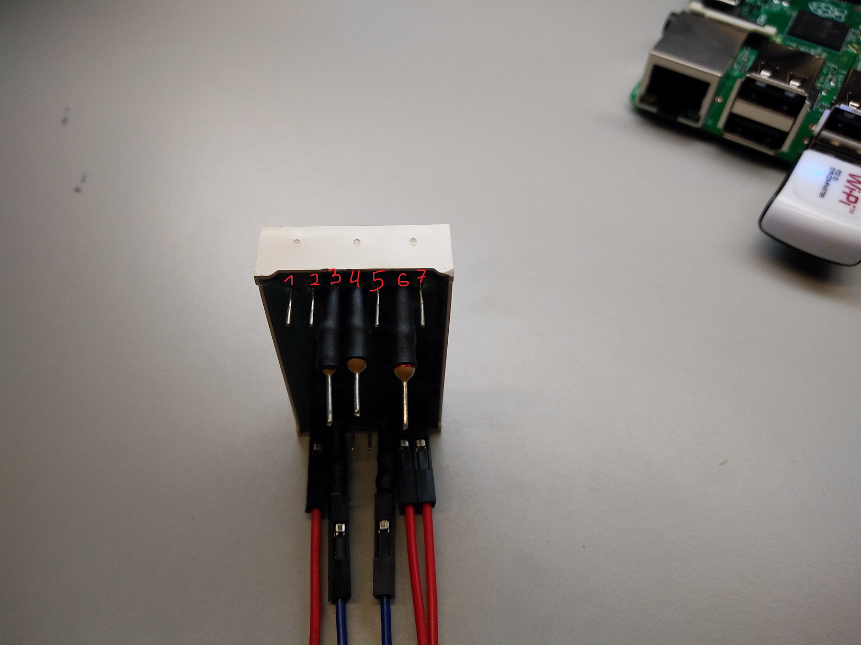
You can see that on one side of the display there are three small dot-like markings. This marks the bottom of the display. The pin one the left is marked as pin 1 and pin numbers increase to the right. You can see that some of the pins (3, 4, 6) have resistors attached to them. We have attached resistors to the column pins to limit the current. If you look at the display from the front, the pin number increase counterclockwise, so pin 1 will be bottom left and pin 14 will be top left. This can also be seen on the following drawing in the top left:
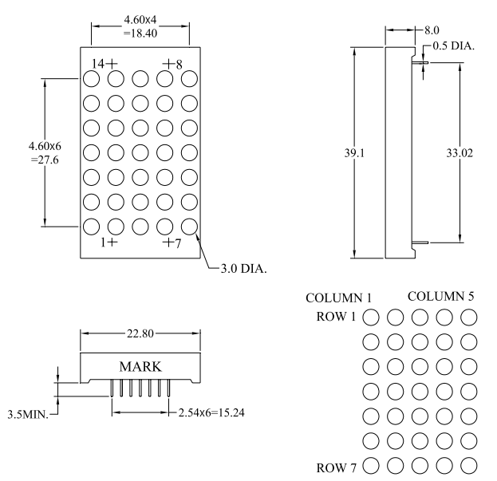
In the bottom right you can see that when looking at the display from the front with it being upright, the column numbers increase from left to right, while to row numbers increase from up to down. You need to determine which pins on the dot matrix display control which rows/columns. This information is available on the following diagram:
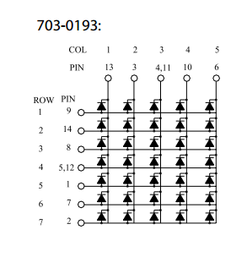
On this diagram, you can see that between every row and column pin there are LEDs, with anodes (+) connected to rows and cathodes (-) connected to columns. As seen in the top of this image, column 1 is connected to pin 13, column 2 to pin 3, column 3 to pins 4 and 11 and so on.

Now we will connect the dot matrix display to the Raspberry Pi using the RPi GPIO header. Here you can see the pin diagram of this header:
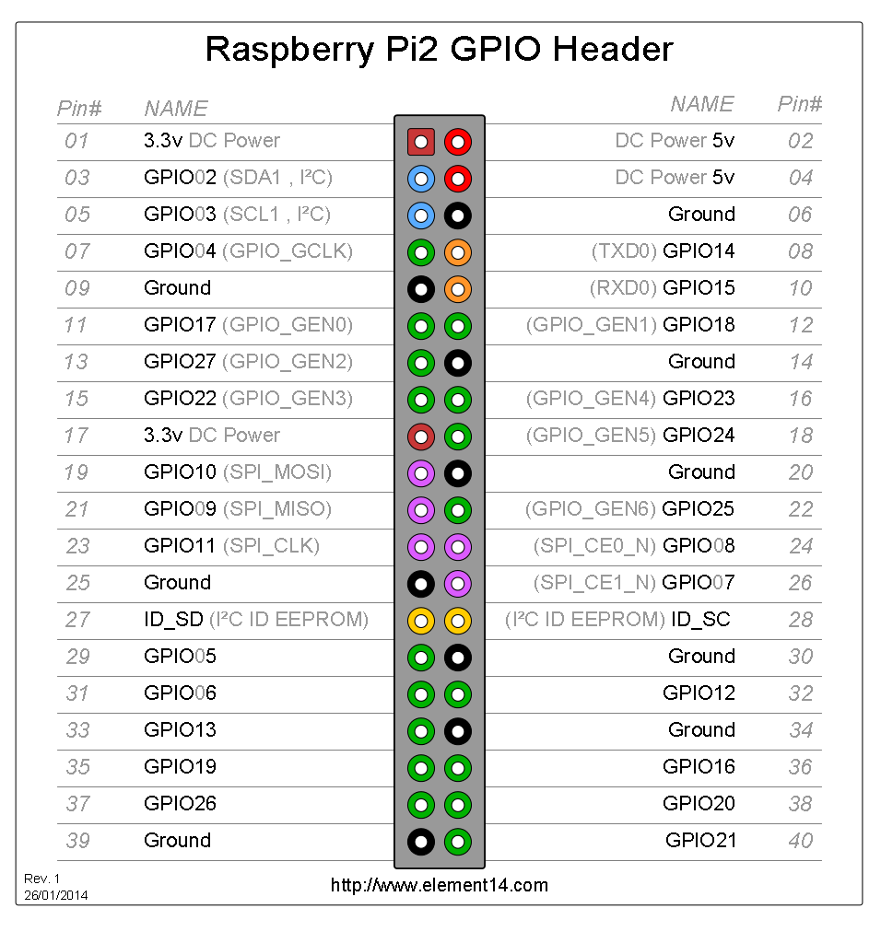
https://www.element14.com/community/servlet/JiveServlet/previewBody/73950-102-4-309126/GPIO_Pi2.png
This schematic matches pin names (as used in software) and numbers to the physical layout of the connector. Pin 1 (top left) is the pin located closest to the Power LED on the Raspberry Pi. You will notice that some pins have GPIO written next to them while others do not. You should connect the dot matrix to only the pins that have GPIO written next to them, as these can be freely controlled.

Attention!! Turn off and unplug your Raspberry Pi before connecting cables!

Connect the display pins as following:

DOT MATRIX | RPI HEADER
Column 1 (pin 13) | GPIO05 (pin 29)
Column 2 (pin 3) | GPIO06 (pin 31)
Column 3 (pin 4) | GPIO13 (pin 33)
Column 4 (pin 10) | GPIO19 (pin 35)
Column 5 (pin 6) | GPIO26 (pin 37)
Row r1 (pin 9) | GPIO25 (pin 22)
Row 2 (pin 14) | GPIO08 (pin 24)
Row 3 (pin 8) | GPIO07 (pin 26)
Row 4 (pin 5 OR 12) | GPIO12 (pin 32)
Row 5 (pin 1) | GPIO16 (pin 36)
Row 6 (pin 7) | GPIO20 (pin 38)
Row 7 (pin 2) | GPIO21 (pin 40)

The red wires on the following image show how the row cables should be connected:
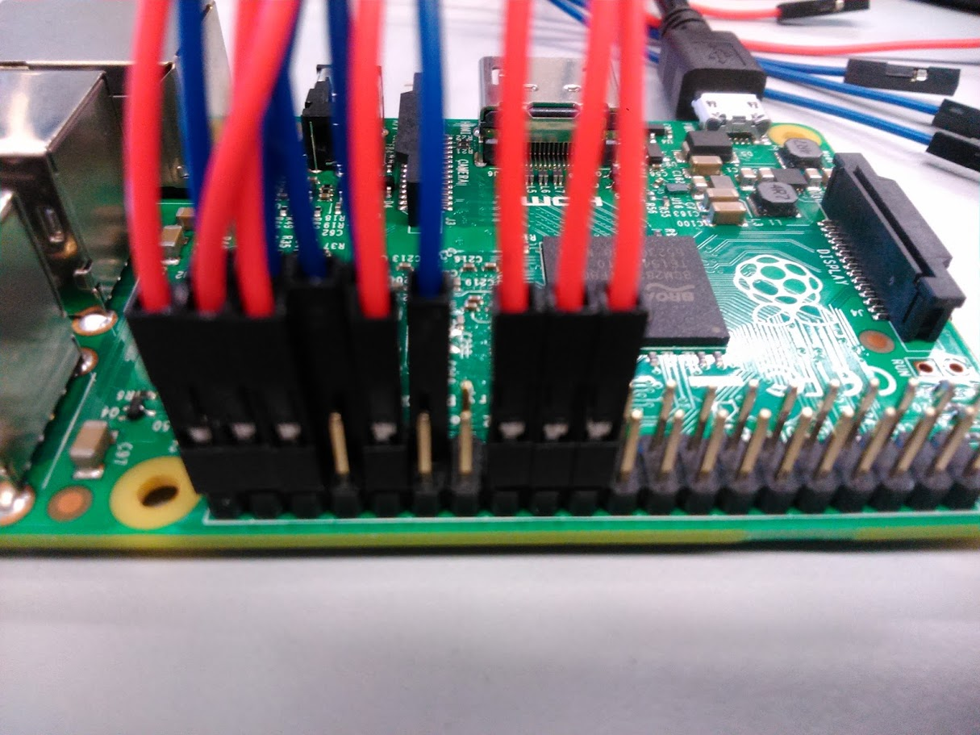
Here you can see how the blue column cables should be connected:
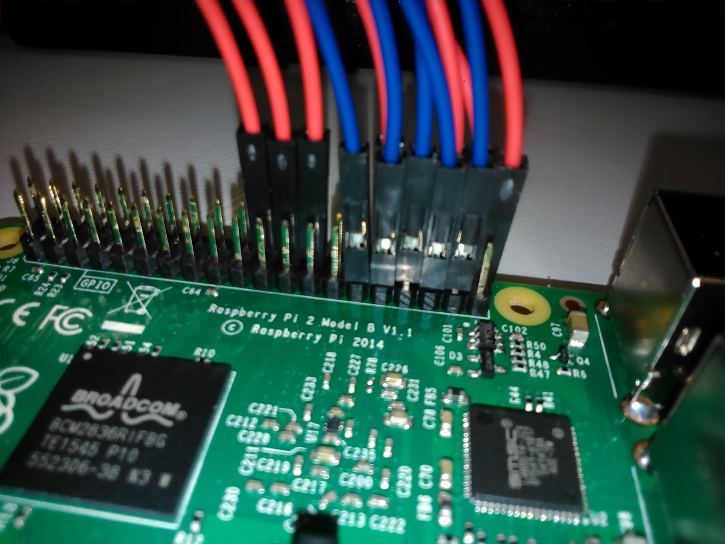
If you are not sure about your electrical connections, ask an instructor to check them. There is also a sample in front.

Using the display

Useful information
Raspberry Pi GPIO usage tutorial can be found here:
https://sourceforge.net/p/raspberry-gpio-python/wiki/BasicUsage/

Control algorithm
The display can be controlled with the following algorithm:
- Set all pins that you connected to the dot matrix as outputs
- Set all column pins high (True) and all row pins low (False) to deactivate all LEDs
- Display your symbol on the display one row at a time:
  - Set all the column pins low that you want to light up.
  - Set the single row pin high that you want to light up.
  - Wait for a small amount of time
  - Set the row pin low and proceed to the next row

Sample code
To run code that uses Raspberry Pi GPIO pins, you need to use sudo.

The following sample code lights up 3 LEDs in the centre of the display for a small amount of time. You can probably see them blinking. Try changing the wait_time variable to better understand how the display works:

This code is also uploaded in Moodle. To download it:
- go to course Moodle page on Pi
- right click on dot_matrix_example.py → open in new tab
- right click on 3.py → save as

import RPi.GPIO as GPIO
import time

# reference pins by GPIO numbers
GPIO.setmode(GPIO.BCM)
# disable warnings
GPIO.setwarnings(False)

# define row and column pin numbers
row_pins = [25, 8, 7, 12, 16, 20, 21]
col_pins = [5, 6, 13, 19, 26]

# set all the pins as outputs and set column pins high, row pins low
GPIO.setup(col_pins, GPIO.OUT, initial=GPIO.HIGH)
GPIO.setup(row_pins, GPIO.OUT, initial=GPIO.LOW)

# Sets the waiting time between rows. With larger wait times (0.1) you can see that rows are lit up at different times. With smaller times (0.01) the LEDs appear to be not blinking at all
wait_time = 0.05

# Displays image for a set number of times
for i in range(50):

# sets column number 3 low
GPIO.output(col_pins[2], GPIO.LOW)
# sets row number 4 high, this should light up the middle LED
GPIO.output(row_pins[3], GPIO.HIGH)

# wait
time.sleep(wait_time)

# set the pins back to previous states
GPIO.output(col_pins[2], GPIO.HIGH)
GPIO.output(row_pins[3], GPIO.LOW)

# sets columns number 2, 4 low
GPIO.output(col_pins[1], GPIO.LOW)
GPIO.output(col_pins[3], GPIO.LOW)

# sets row number 5 high
GPIO.output(row_pins[4], GPIO.HIGH)

# wait
time.sleep(wait_time)

# set the pins back to previous states
GPIO.output(col_pins[1], GPIO.HIGH)
GPIO.output(col_pins[3], GPIO.HIGH)
GPIO.output(row_pins[4], GPIO.LOW)

# reset GPIO
GPIO.cleanup()

Tasks
- Control a single row/column. For example like this:
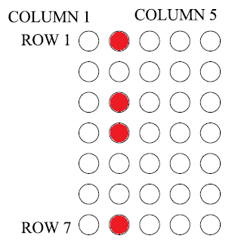
- Control entire display. Try to show following images:
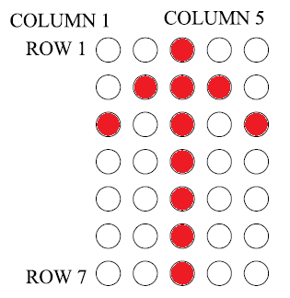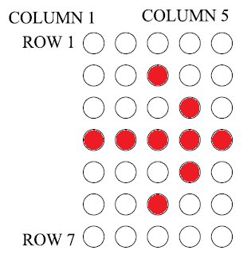
Show it to instructors when finished.
- Show at least one custom picture or letter and show it to instructors.

Character LCD

What you need:
- Raspberry Pi with accessories
- Adafruit 16x2 character LCD with I2C interface
- 4 pin Male to Female jumper cable

Connecting display to Raspberry Pi
Attention!! Turn off and unplug your Raspberry Pi before connecting the display!

To connect this display to your Raspberry Pi, you need a 4-wire jumper cable.

This device was designed to fit on top of the Raspberry Pi. Connect it so that pins 2, 3, 5 and 6 are connected to their corresponding pins on the LCD. The result should be like this:
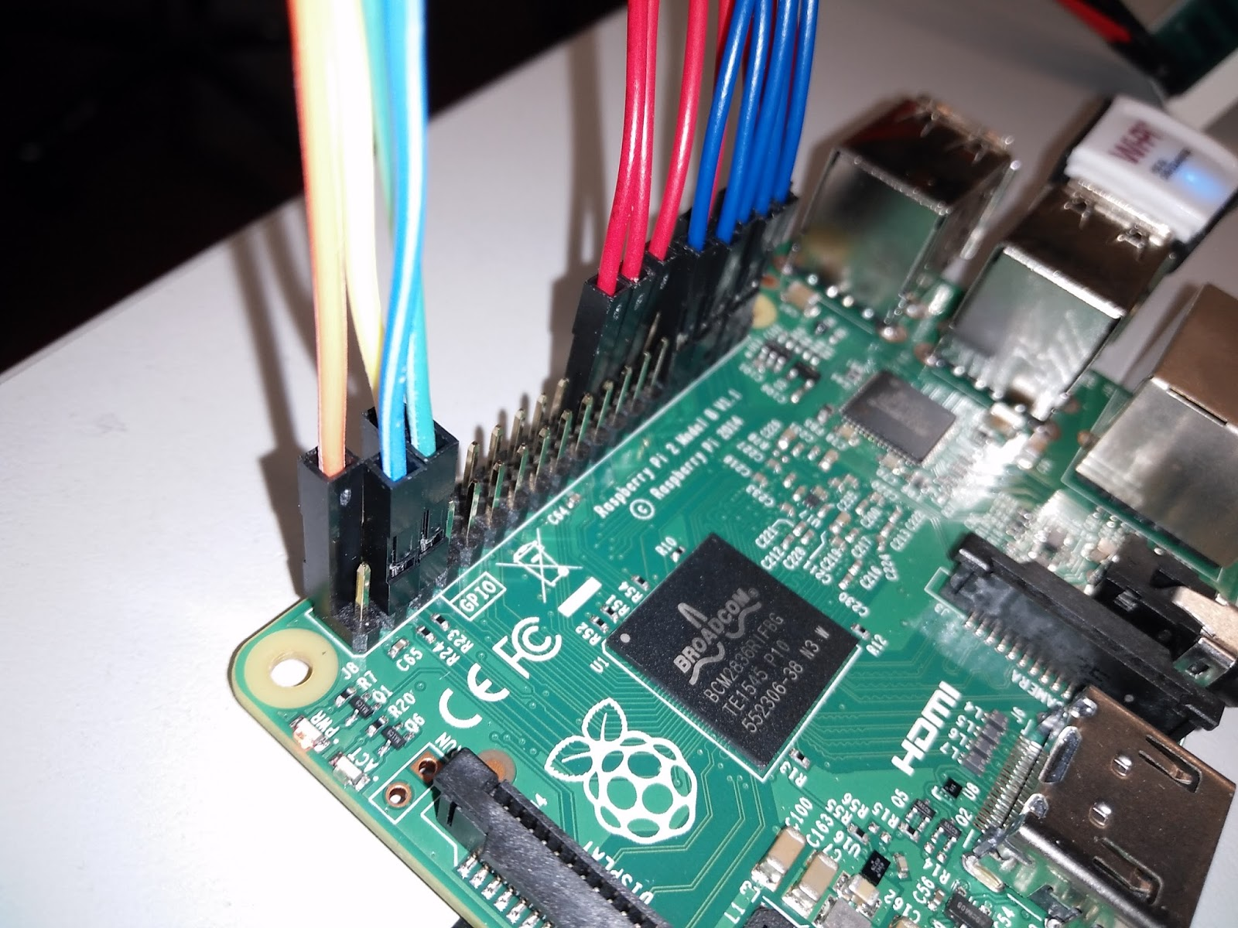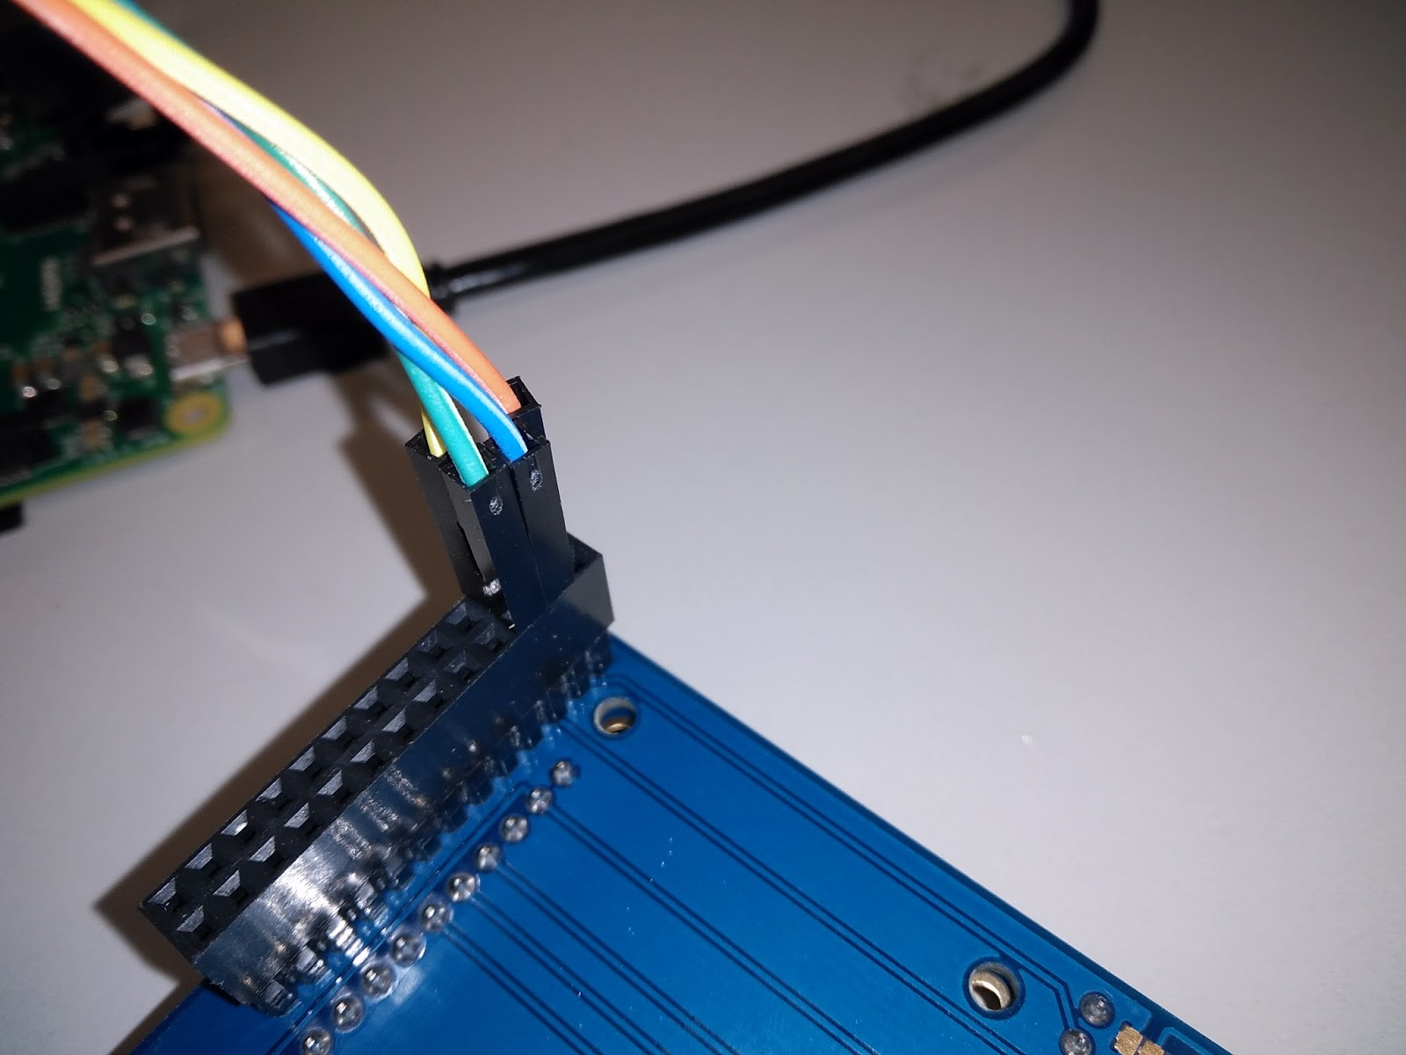
If you are not sure about your electrical connections, ask an instructor to check them. There is also a sample in front.

Software prerequisites
Open the following guide:
https://learn.adafruit.com/adafruit-16x2-character-lcd-plus-keypad-for-raspberry-pi/usage

Work through it to install all the necessary software. Most likely you will only use the following commands:
git clone https://github.com/adafruit/Adafruit_Python_CharLCD.git
cd Adafruit_Python_CharLCD
sudo python setup.py install

Run the test code to see if you have everything configured properly.

Using the display
First you need to import the LCD API:
import Adafruit_CharLCD as LCD

Now you need to initialize the LCD with the following function:
lcd = LCD.Adafruit_CharLCDPlate()

To set the backlight color of the LCD:
lcd.set_color(R, G, B)
Here R, G and B can be either 1 or 0, to activate or deactivate the corresponding color.

The following function clears all text on the display and resets the cursor to the first character:
lcd.clear()

You can use the following function to display data on the LCD:
lcd.message('text here')
You can insert a ‘\n’ symbol to this text to change the line.

To check if the left button is pressed:
lcd.is_pressed(LCD.LEFT)
This function returns a boolean value (either True or False)
For other buttons, you need to replace LEFT with the corresponding button name.

Tasks
- Write code that measures Raspberry Pi CPU temperature and and current time and displays it on LCD when select button is pushed. Show it to instructors when finished.

To get CPU temperature import the os module
import os

To get current time import the time module
import datetime

You can use the following function to read the temperature:
# Return CPU temperature as a character string
def getCPUtemperature():
res = os.popen('vcgencmd measure_temp').readline()
return(res.replace("temp=","").replace("'C\n",""))

The following functions can be used to get the time:
def getTimeText():
t = datetime.datetime.now()
hours = str(t.hour)
minutes = str(t.minute)
seconds = str(t.second)
timetext = hours + ':' + minutes + ':' + seconds
return timetext

